Kept Apart

Couples and families separated by the UK immigration system

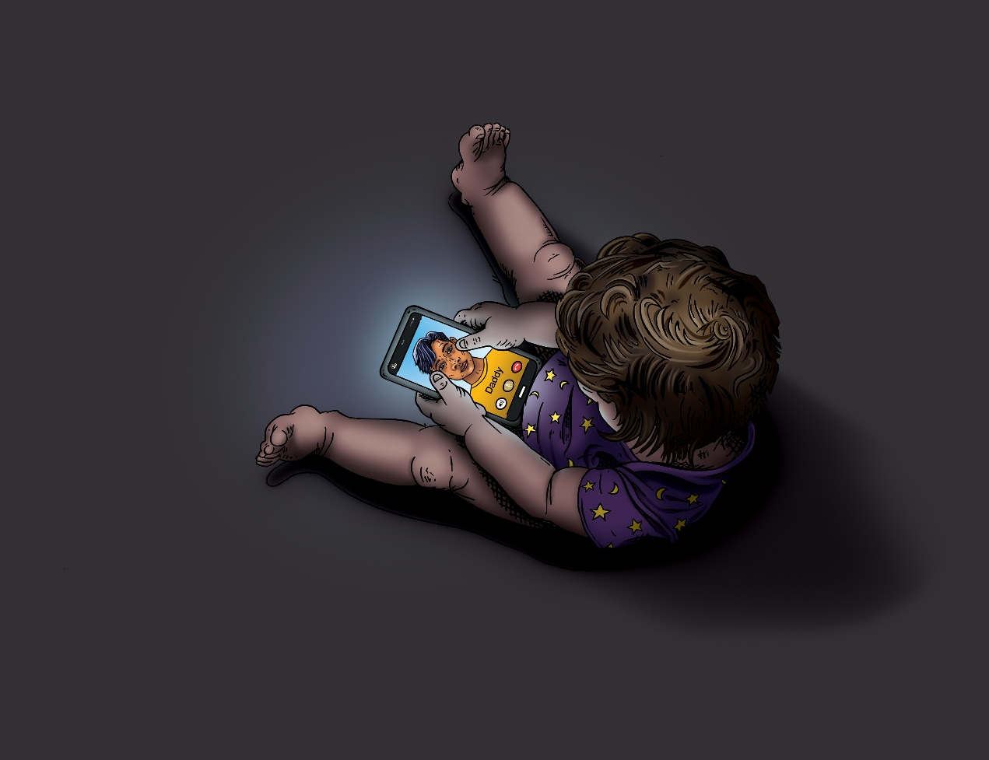

Members of Reunite Families UK
With
Katharine Charsley, Rissa Mohabir, Caroline Coombs, Paige Ballmi, Emma Agusita, & Helena Wray.
Illustrations: Michael Grieve.

Contents

1. Introduction
2. Love
Amanda and Freddy’s Story
3. Deciding my fate
Costs of making an application for a spouse visa for the UK
Sophia’s Story
4. Loneliness
5. Lifeline
Jack’s Story
6. Impacts on health and wellbeing
Grace’s Story
7. Living with Separation and Uncertainty
Daniel’s Story
8. Conclusion
Love in a time of Covid-19: Lilly’s Story
9. Sources of support
10. References

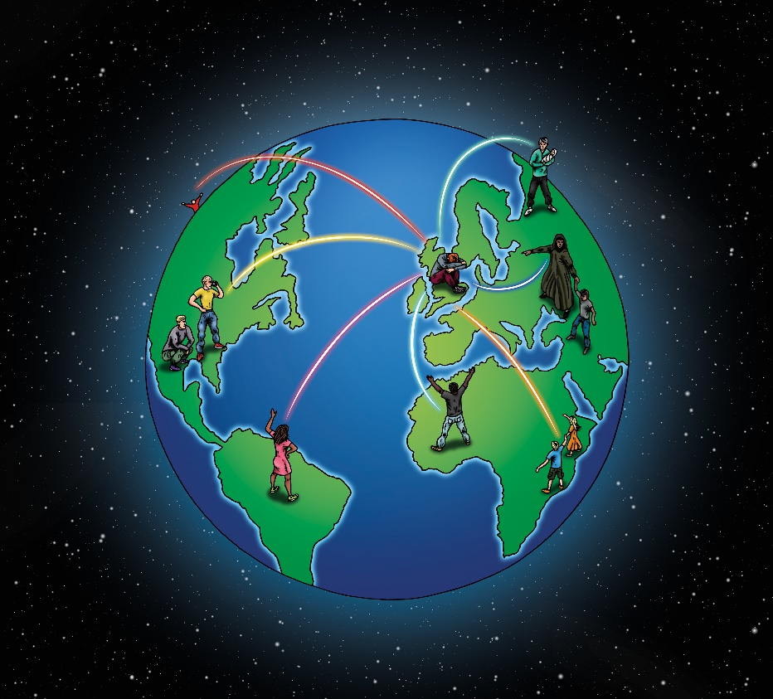

Introduction

In 2012, the British government introduced new restrictions to family immigration, including an income requirement for British citizens and settled residents seeking to bring their spouse, partner and/or children to live with them in the UK. The minimum income was set at £18,600, with additional sums for each child who is not a British citizen. This level was well above the full time minimum wage, is higher than the annual income of nearly half the UK working population, and particularly impacts on women (over half of whom do not earn the required sum), and those in lower-income regions of the UK (Newman 2017, Sumption & Vargas-Silva 2019). The alternatives based on savings are similarly out of reach for many. Couples who meet whilst working, studying or holidaying overseas (or indeed through internet fora) and who wish to stay in or return to the UK therefore find their futures unexpectedly dependent on an increasingly restrictive immigration system (Agusita 2018,2019). By 2015, an estimated 15,000 children had been deprived of a parent by the immigration regulations (Children’s’ Commissioner 2015). To make matters worse, under a recently out-sourced visa service, waiting times for immigration decisions have lengthened whilst fees have increased dramatically, and reported errors in visa refusals are high – reflected in the majority of first tier immigration appeals being granted (MoJ 2019, Bulman 2019). Even those whose applications are successful in the end can therefore face lengthy periods of uncertainty and separation (Agusita 2018, 2019).
Earlier restrictions to family immigration, such as the notorious ‘Primary Purpose rule’, particularly affected British South Asian populations (Sachdeva 1993, Wray 2011) and led to the creation of ‘immigration widows’ (Menski 1999). With cross-border marriage common in some of these populations, however, individuals could often access support from family and friends with experience of negotiating the immigration system (Charsley 2013). The range of couples and families affected by the 2012 regulations is now much more diverse. The British participants in this project had partners from a range of countries including the USA, Kenya, Turkey, Ghana, Albania, Mexico and the Philippines. They included men and women, couples with and without children, established families seeking to return to the UK, and those hoping to live together as a couple for the first time. Those now kept apart by the UK immigration system often do not know others who have been in this situation, and can experience isolation, stigma, and distance from those around them who may not understand what they are going through. Indeed, in an era of increasingly open xenophobia and racism, families and friends may not always be supportive of inter-national partnerships. Mainstream support organisations are often not familiar with the difficulties faced by people in this situation. As a result, many turn to internet communities for advice and support with the practical, bureaucratic, emotional and financial stresses of the processes and outcomes of the family immigration system.
This book grew out of an initiative by one internet community, Reunite Families UK, in collaboration with academics at the Universities of Bristol, Exeter and the West of England, funded by the Brigstow Institute (University of Bristol). Together with the specialist organisation ‘Trauma Awareness’, we designed a listening project to explore the experiences of British partners separated from their spouses and/or children, including how they live with the uncertainty of their situation, and to experiment with face-to-face support to address the trauma reported by many Reunite Families UK members. The arrival of the 2020 Coronavirus crisis part way through the project meant that the second half of our work together was completed online. However, Covid-19 also brought new significance to the project, not just because travel restrictions and service disruptions exacerbated separations, delays and uncertainty for those negotiating the family immigration system, but because social distancing and the shielding of vulnerable individuals meant that the experience of family separation became one which was shared by so many more British families during this period.
This co-produced book combines the words and experiences of ten workshop participants, transcribed by Natalie Jaifar, with illustrations inspired by their stories. The artist drew on his own experiences of the UK's family immigration regime: having left the UK to remain with his wife whilst she applied for a spouse visa, when her application was refused, he faced a difficult choice between separation or being trapped in exile. They remain together overseas. This option is not, however, available to everyone – as several participants’ stories will illustrate. We also provide background information on the family immigration system, and a list of sources of support. We hope that this book will serve two purposes: first, to highlight the traumatic impacts of separation of spouses and children by the UK immigration regulations; and second, to provide a resource for those finding themselves facing such separation, who may benefit from the stories and advice of others who have been in this situation.

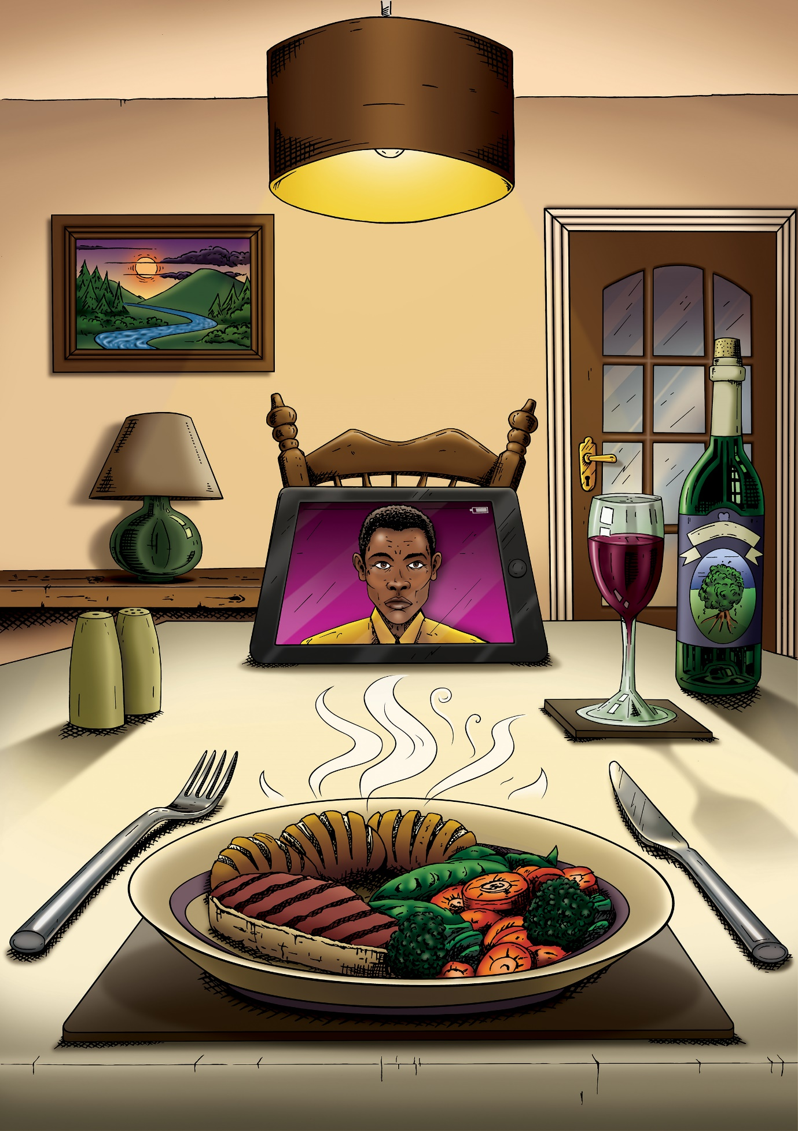

Love

I am in this situation through LOVE. Love of others, and other cultures.
If I hadn’t been to Tanzania, I would be a different person - it’s the best thing I did in my life.
Our wedding day was the best day of my life -
I’m glad I didn’t know what was going to happen.

Proving our relationship,
Judged, objectified, dehumanised.
Guilty until proved innocent.

Heathrow Arrivals: will he be allowed in?

What is needed? Have I got it right?

Will he be here for the birth of our son?
People don’t understand.
I get asked: ‘What has your husband done wrong
that means he cannot live here?’
‘You have a child – doesn’t that mean he can live here?’

The stress it puts on your relationship,
For what should be a a natural normal thing.

Relationships are tricky anyway.

It feels like being punished just because we fell in love with a foreigner.

Love is what keeps you going.

Amanda and Freddy’s Story

February 2014
I was living in China, teaching English. I went to a local bar with friends as a new band were arriving. We sat at a table right in front of the stage. Whilst the band were playing, Freddy (the lead guitarist) brought his guitar over to our table and began playing it as he looked right at me. All I thought was, ‘Can you believe this guy?’ When the band finished playing, he came over to my table with drinks. We talked and talked. My friends left and the bar emptied but we stayed until we were the only ones left. He loved Greek mythology and so did I. His eyes were a beautiful brown. We moved closer and closer to each other until a kiss was inevitable. It was passionate and filled with a desperation to be as close to one another as possible. I held his hand and led him out of the bar. We spent the night together and talked until the sun came up. We fell asleep in each other’s arms and awoke in the same position. We saw each other every day since.
A few months later, we discover I’m pregnant. We haven’t been together long, but everything feels right. We had enough love to share. I return to the UK to give birth. Freddy cannot come with me because we couldn’t afford for him to stop working. Oscar is born in December 2014 and introduced to Daddy through Skype. Three months later we return to China where Daddy and Oscar meet for the first time. We notice Oscar has a developmental delay so decide on returning to the UK to raise Oscar there would be the best decision for the whole family.
In March 2018, myself and Oscar return to the UK. Oscar starts attending a local nursery, and I continue the search for a job that pays over £18,600 (the Minimum Income Requirement). This was incredibly difficult - I had many interviews but struggled to find the right hours as a single parent.
Two months later, I finally got a job as a teaching assistant as I was in desperate need of income and loved working with children. But it did not meet the income requirement.

Oscar’s nursery informs me they cannot take Oscar full time due to his needs. I move him to a private nursery and they refer him to the Special Educational Needs Inclusion team. He still can’t talk.

We apply for Disability Living Application but are refused because we had been back in the country for less than two years. This was a chance to get more help for Oscar and would have brought us one step closer to our family being whole again. I rang them and asked for a mandatory reconsideration. The woman on the phone was incredibly insensitive: she said, ‘I’m not saying he’s not disabled – you haven’t been in the country long enough.’ This news caused me to become very low. I felt numb. I needed to find a light at the end of the tunnel. Freddy joining us seemed even further away.

Oscar was finally diagnosed with Autism. This was a huge relief as it meant he would be able to access support - he would never have got the help he needed in China. I have sacrificed two years of my marriage to give my son the best possible chance in life, but we shouldn’t have had to go through all of that without a husband or father.

Important dates missed:
Oscar’s first day of school – no Daddy.
Freddy’s mum passed away – no wife.
My 30th birthday – no husband.
Oscar’s 5th Birthday – His second birthday without his Daddy.
Christmas – Our second Christmas without Freddy. This one seemed even more difficult than the last. I feel trapped and alone.

January 2020
Freddy travelled to the Philippines to visit his family just as the Corona Virus outbreak in China becomes global news. Filipino President blocks all its citizens from returning to China. This is
still in effect. Freddy has had no salary for two months. Fingers crossed he can return to China to work and stay safe.

March 2020
We will be able to reapply for Disability Living Allowance. If granted, we may be exempt from the Minimum Income Requirement. I’m holding onto my sanity with a vice grip but if this fails, I am scared of my own desperation.

Deciding my family’s fate

Applying for a partner visa is difficult, time-consuming, emotionally draining and expensive, but it does not have to be like this. Applications used to be much more straightforward. This changed in 2012 when the minimum income requirement was implemented alongside very specific and detailed requirements as to how that income must be demonstrated. The overall cost of applications skyrocketed. There are also many additional costs, from the health surcharge to language tuition to lawyers’ fees for an appeal. The cost from application to getting ‘Indefinite Leave to Remain’ (i.e. the right to stay in the UK long-term) is, at a minimum, more than £7,000 - as the table overleaf shows.
Couples must start planning their application months or even years in advance to ensure they have a sufficient financial track record and can pass the English language test (if needed). The application must comply exactly with the Immigration Rules - criticised by lawyers, campaigners and even Supreme Court judges for being so complex that even immigration law experts find them difficult to understand. A successful application requires microscopic attention to detail and the ability to co-ordinate the production of a large number of time-sensitive documents in precisely the right format. A mistake can send you back to the starting point, only several thousand pounds poorer. Many people never apply at all because they cannot afford to.
Once the application has been made, the waiting begins. How long an application takes to be decided depends on a range of factors, including whether you have paid extra for a premium service, but most couples end up waiting months. Applicants may be refused because they have failed to meet one of the many technical requirements or because of errors by the decision-maker. In other cases, the immigration service does not believe that the relationship is genuine even when there is plenty of evidence to show otherwise. It is difficult to get the Home Office to remedy their own mistakes and refused couples often have to embark on the lengthy, uncertain and expensive route of a Tribunal appeal (where grounds of appeal against refusal are now much narrower than before).
Even if the initial application is successful, that is only the first stage. Another expensive and exhausting application must be made after 2.5 years and a further one 2.5 years after that. For at least five years, you cannot afford to lose your income or to need state support. Decisions about how to live your life – whether to have a family, to change jobs, to start a new business, to go travelling – are limited by the need to ensure that you can meet the next stage of the process. If you are lucky, after those five years, your partner receives indefinite leave to remain and life can begin to feel more secure. If you are not, something goes wrong, and you are stuck on the treadmill of repeated applications.
Participants in the Kept Apart project were at various stages. Some participants’ partners’ visa applications had been refused, some had been refused in error despite meeting the spouse visa requirements, whilst others did not have the financial resources even to be able to apply. Several had eventually been reunited with their spouses (e.g. after a successful appeal) whilst others were still living in separate countries. The length of time participants had endured this separation from their partners (and children from parents) ranged from nine months to seven years.

Costs of Making an Application for a Spouse Visa for the UK

Process | When paid | Current fees
English language tuition and testing (A1 speaking and listening) | Before application (if required) | Variable
Medical testing | Before application (if required) | Variable
Translation of documents | Before application (if required) | Variable
Visa fee | On application | £1,523 plus extra for priority (£573) or super-priority (£956)
Health surcharge  (fee to use the NHS) | On application | £1,200
Biometric Appointment (to view original documents) | On application | £0 to £110
Further leave to remain | After 2.5 years (and sometimes 5 and 7.5 years) | £1,033
Health surcharge | Every 2.5 years after entry | £1000
English language tuition and test (B1) | Before applying for indefinite leave | Variable
Life in the UK test | Before applying for indefinite leave | £50 plus handbook
Indefinite leave to remain | Between five and ten years after entry | £2,389
Legal Advice (Optional) | Before application / at any stage | Variable
 | Minimum Total: £7,195* | For a single applicant, excluding optional and variable fees. Further costs for appeal if application rejected.
Costs, estimates and requirements correct at time of publication, but are subject to change.

Deciding my Family’s Fate

The Refusal letter
Life went downhill after that
Who decided my family’s fate?
‘CLS19’ [the processing officer’s ID]

Insulting, hostile, harsh rules
Like a cold hungry machine,
Spitting people out.
We are one!

Money, money, money!

How much money?
Just me – are you serious?
Working sixty hours per week,
Working through the pain.

The big ‘Why?’, with no answer.

Getting it right
Collecting documents
The horrible bank stamps
With time frames to have them ready

Applications like a task in a fairy tale
More, More and More!

MISTRUST
Fear of refusal
Lack of trust in the system
Refused even when submitted everything
Where barriers and hostility
Makes me feel like a criminal

SHAME
Shaming - being shamed.
Sexist comments.
‘Why didn’t you think to check the situation before you fell in love?’
You are gullible and stupid -
You must have been tricked for a visa.
A huge insult.

BETRAYAL
I feel betrayed by my own State, my own country.
I was raised to explore the world – then punished for it.
The UK embraced the world; now it locked the door.

INJUSTICE
Faith in humanity is questioned.
The system is letting me down.
Constant injustice lights fire in my belly.

'My life before was about helping others in Greece – refugees and orphans – before I met my husband. Now I am in [the immigration] process myself. When I returned to Greece, I could relate to them in a new way. I drew from the refugees’ strength, coming together through shared experiences. Educating others can give us strength – challenging prejudice. The system is letting you down - the injustice keeps you going.’

‘We lived in California. Now we are here, I am livid. I can’t accept that a country I thought was good has turned into a vicious, segregated society. I feel less of a person having been through the [immigration] system. I want to feel that I am as valuable as I felt before. I want equilibrium again.’

Sophia’s Story
In the summer of 2016, we (my husband, myself and our 6-year-old daughter) had been living as a family in Turkey for six years. We considered moving back to the UK on many occasions. In 2012 my father suddenly died, leaving my elderly mother alone. But that year Theresa May also introduced the Minimum Income Requirement – if we returned to the UK, I would need to earn £18,600 for a period of 6 months before we could apply for a visa for my husband to join us. We made the difficult decision to stay in Turkey where my husband could continue his career as an English teacher while I could be a full time Mum to give our daughter the best start possible.
The military coup in the summer of 2016 changed everything. Our daughter’s school closed down overnight. Some of my husband’s friends and colleagues were being suspended from their teaching jobs, and some were being arrested. My husband wasn’t involved with anything relating to the coup, but lists kept coming out of the teachers who were going to be next. It was very worrying, and we depended completely on my husband’s income. It was then we needed to make a decision. We knew we would have to go through some separation, but as a teacher myself, I felt it was possible to earn the Minimum Income, so we thought that in 6-8 months we could be applying for the visa, so we made the decision to relocate to the UK. My daughter and I packed up our belongings and moved to the UK, living with my Mum – temporarily, we thought, until we could find our feet. Our daughter started school locally and I began the search for work. I applied not just for teaching jobs but any kind of job that I thought would earn the £18,600, but there was nothing coming up where we lived (an area known for lower wages). I finally took on a temporary part time post which paid less than the Minimum Income Requirement.
At Christmas 2016, I noticed something very strange – our daughter had stopped talking to anyone other than myself and my Mum. She refused to Skype her Baba (dad) as, in her words, she “missed him too much”. She was very anxious – every morning when I left for work, she was screaming at me not to leave her. This was just terrible to experience. After all my stay-at-home nurturing in a settled family, her life was suddenly turned upside down. Not only had she lost her Baba, she had lost her Mum to the world of work as well. My job wasn’t even helping to get her father here. She was suffering but I had to work. I had to keep looking for jobs to meet those requirements.
I went to the GP about our daughter. Over a period of two years, she was diagnosed with selective mutism, separation anxiety, stool holding, and anxiety so extreme that she collapsed twice and had to go to hospital.
I eventually managed to get a job which met the income requirements, at a school in OFSTED special measures. I cannot tell you how tough this job was, doubly so as I was suffering with my own daughter’s needs as a forced single parent. I don’t know how I got through it. The stress was like no other. I struggled to function at all.
We finally managed to apply for the visa after almost two years of being separated. It was touch and go all along as there were restrictions on travel because of the state of emergency in Turkey following the coup. My husband also had to give up his job so that he would be able to travel within the permitted time when he got the visa, so I had to support him financially for several months on my meagre salary.
The week that my husband arrived in the UK, my daughter improved significantly. The stool holding stopped overnight, the separation anxiety completely stopped, and the selective mutism has gradually improved over time since. We don’t yet know what long-term effects this has had on her.
My own health has been up and down. I display symptoms of stress, anxiety and post-traumatic stress disorder. I gave up teaching for over a year to help my husband settle and to give my daughter a normal life again. With the trauma I had been through, I don’t think I could have coped with working anyway. I was very lucky that my husband was able to find a job to keep us ticking over. But we are both struggling to rebuild the life we should have had. My husband is well educated, yet he finds himself stacking shelves in a supermarket – the only job he could get an interview for. But he is doing well and may be able to train to become a line manager. I have finally returned to teaching part-time (after much persuasion, as my self-esteem and confidence took a complete nosedive after these horrendous few years).
The impact this process has on a family is difficult to describe. Your life cannot take the usual direction you would expect and the financial costs – not just of visa fees but loss of earnings, and the deskilling. Despite his teaching career and English language degree, my husband still had to take the English test – we had to trek to the other side of England for the A1 exam as there were none available at the closest test centre, meaning an overnight stay in a hotel and the cost of travel and the exam itself, all for a 5-minute test to prove he can speak the most basic English.
It is still not over. We have the next visa application coming up at the end of this year, yet another 2.5 years to endure before my husband can become a British citizen with the right to stay in the country permanently – only then can his life and our family life become stable here. We are struggling to rebuild. We want to buy a house together but because my husband is on a visa, we need to have a much larger deposit than normal. It really doesn’t seem fair. When friends of our age and younger are saving up for cars, house deposits and holidays, we are saving for visa fees and can barely afford to even visit our family in Turkey. We are in our mid 40s and after four years back in the UK, we still live with my mum. We just want this whole process to be over so we can begin to move forward with our lives.

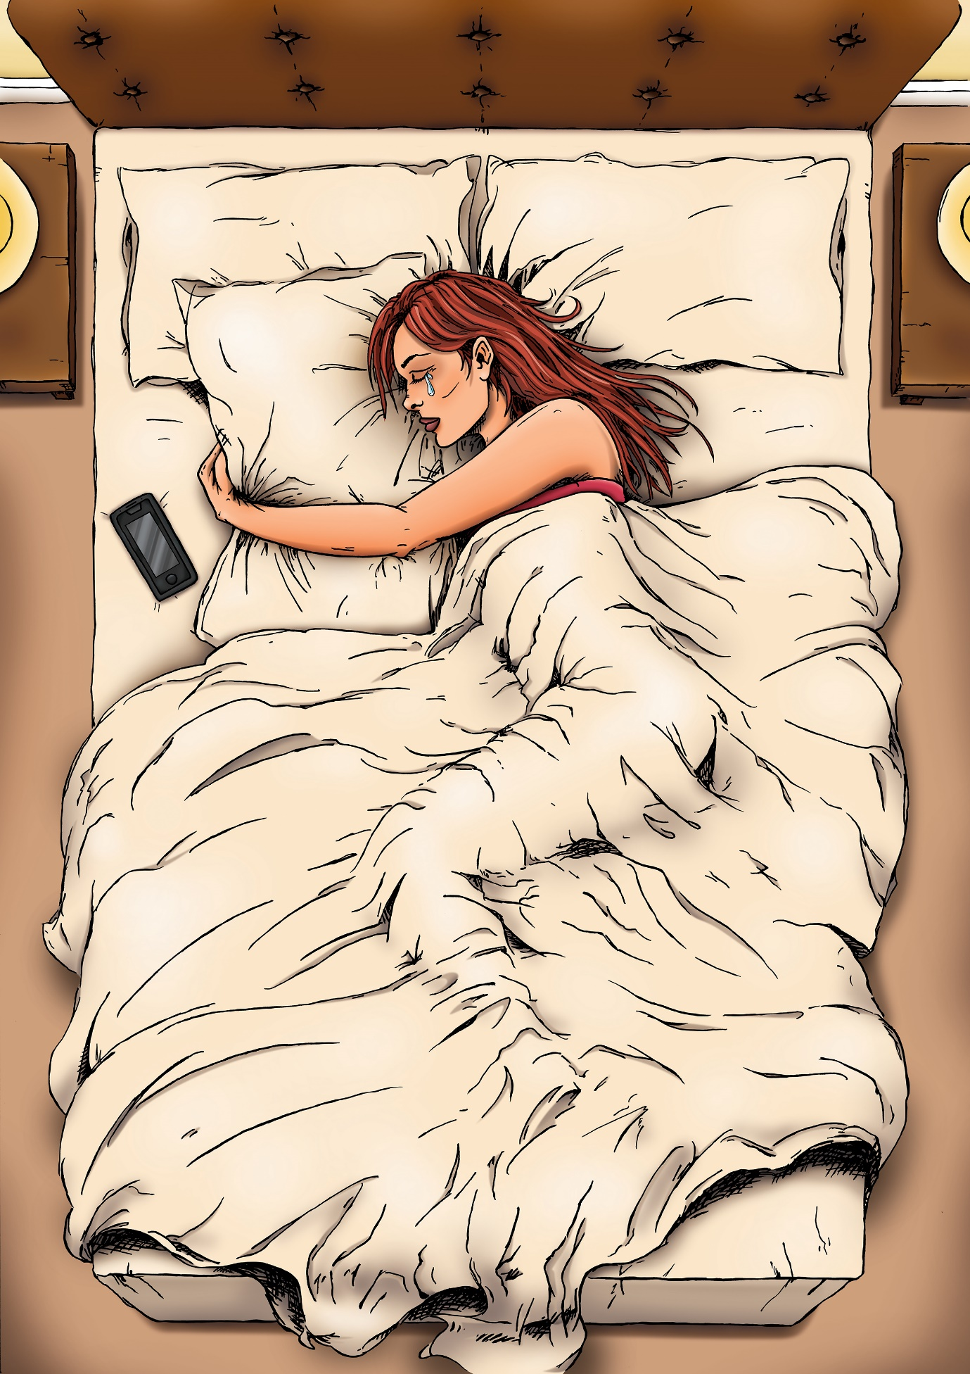

Loneliness

I bought a toy owl.
It looked lonely - the only one on the shelf.
Suffering.
It looked as lonely as I felt.

A pillow became a lifesaver for anxiety.
It filled the space
That should have been occupied by my husband

Searching for affection,
Yearning,
Missing physical contact.
And no sex! No one ever talks about that.

Seven years on hold.

-----

Family separation.
Mothering alone.
Christmas and birthdays mark their absence.
Children feel abandoned, insecure,
Separated, confused.
Not able to speak on the phone.
It’s inhuman.

---
Feeling stuck in limbo,
Wishing life to pass quickly without living,
Empty waiting.
Withdrawing into my grief and sorrow,
Friends and family don’t understand.

Torn Apart

‘Father and son you are almost one
Now they are torn apart
Sent back to beginning,
Still waiting for the start.’

Lifeline

Workshop participants were asked to bring an object that spoke to their experience of separation, and to write a few points of explanation. Some of these objects inspired illustrations, others were incorporated into the prose-poems created from their words. These three images taken at the workshop speak powerfully to the dual experience of communication technology: as a crucial lifeline to maintain connections with loved ones, but also a painfully inadequate subsitute for their physical presence. You can’t hug a phone. A tablet is not a wife. ‘I love and hate this object… It is not enough…’

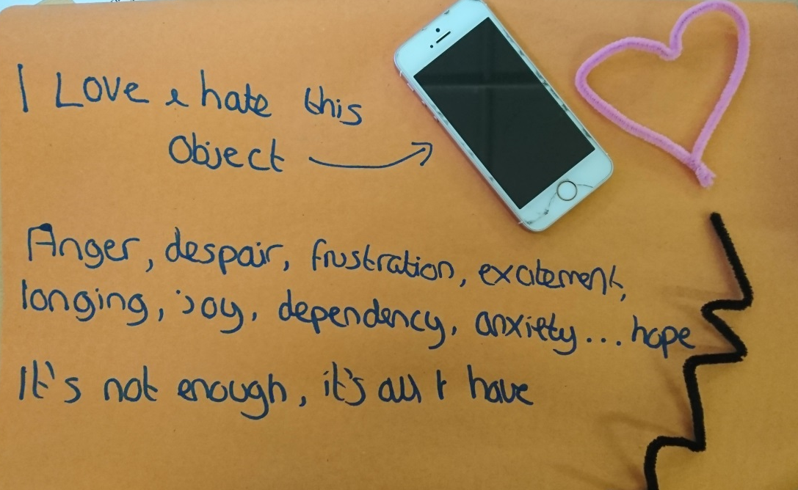

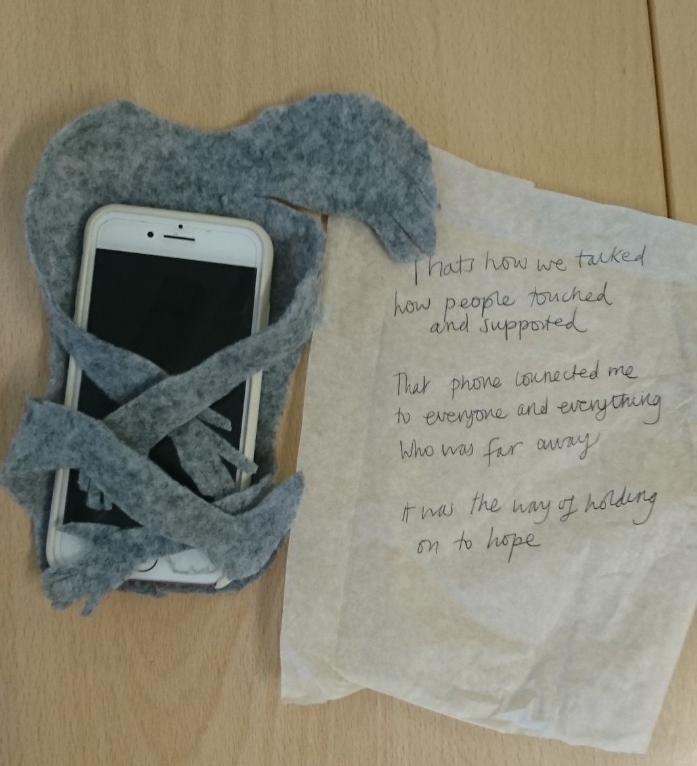

A lifeline to future life,
Bringing me hope for a future
That seemed unthinkable and uncertain.

‘Every now and then I can’t talk to my husband, it is too painful.’

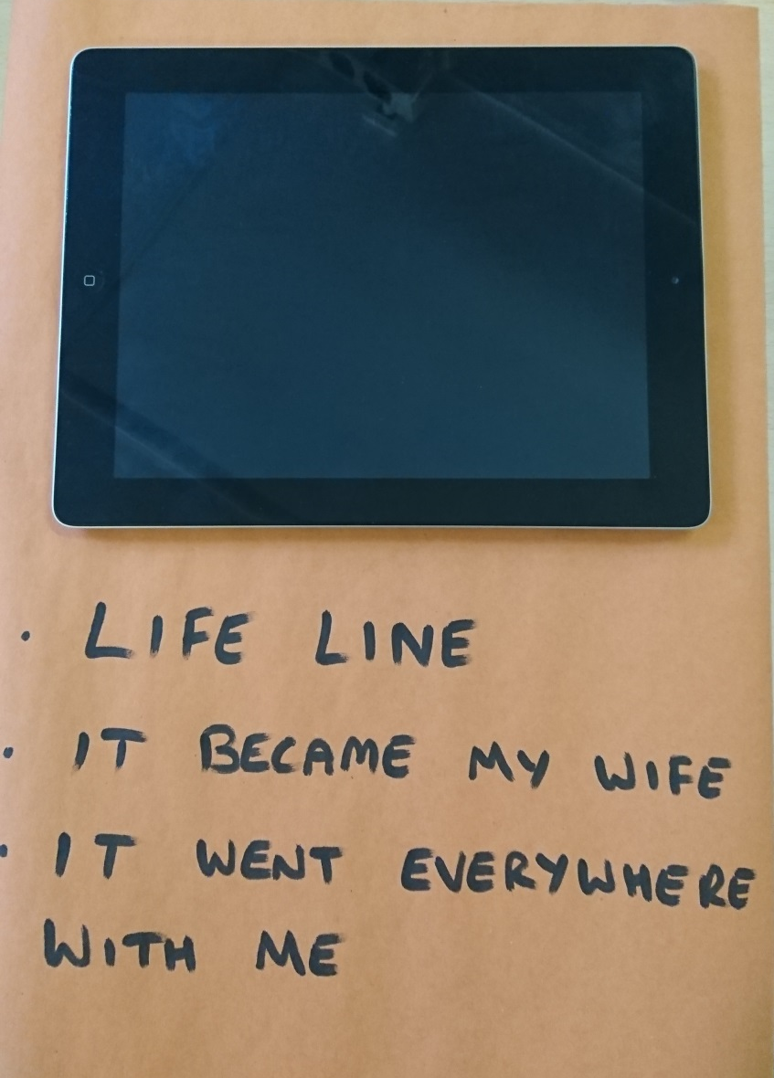

Jack’s Story

I met Isabella through friends who host students from all over the world. They suggested I get in contact with Isabella, who had just finished her studies and gone back home to Brazil. I sent a friend request and message via Facebook, and changed my life. That was back in April 2012.

We spoke for six months on Skype and Facebook and both realised there was something more than friendship there. I wasn’t working at the time because I was suffering with depression, so I didn’t have much money, but I managed to fix up and sell a couple of old motorbikes to pay for flights to Brazil (in November 2012) to finally meet Isabella and her family. It was the best two weeks of my life, but leaving was brutal. I'm not a guy who cries, but I was a mess.

Months passed and we were in constant contact using any platform available, then Isabella came back to England in 2013 to study for 6 months. Just before she was due to go back to Brazil we went on a trip around Europe where I proposed, and we got engaged. When she went back home, we didn’t know when we would be together again. She planned the wedding and in April 2014 we married in Brazil. After the wedding we had only ten days together before I had to go back home, and we were apart AGAIN. Once I returned to the UK, we started looking into visa requirements and that's when the difficulties began: I would have to meet a financial requirement that seemed impossible to achieve. I was devastated.

In 2015 I was working in a coffee shop and earning minimum wage. It wasn’t enough to meet the minimum income threshold even though, as I lived with my parents, my only outgoing was a mobile phone contract. If I earned the required £18,600, but had to pay rent, council tax and all the other bills, could I support my wife? The system is ridiculous!

Eventually the time came for Isabella to go back home and the question “When will we be together again?” was once again haunting us. We were both heartbroken. I decided to roll up my sleeves and meet that requirement. On minimum wage I had to work no less than 60 hours per week for six months without fail. A single day off sick or shift lost during that time meant the difference between being with my wife or being alone. It was the hardest thing I’ve had to do, but the love I had for my wife kept me going, along with the desire to prove people wrong who doubted it was possible.

Impacts on Health and Wellbeing

As many have experienced during the Coronavirus ‘lockdown’, being kept apart from your partner or family can have profound impacts on well being. People kept apart by the immigration system often have no idea of how long the separation will last, or indeed whether they will ever be able to live with their loved-ones again. The situation is compounded by the pressures and uncertainties of negotiating the immigration system. Those with children often have to combine working long hours to meet the minimum income requirement, with adjusting to a situation in which they are effectively a single parent, and taking care of children who may themselves be traumatised by the absence of a parent – as we saw in Sophia’s story in Section 3 of this book (Deciding My Family’s Fate). Echoing earlier findings in a report on the impacts on families and children by the Office of the Children’s Commissioner for England (2015), participants in the Kept Apart project described a range of impacts on their emotional state, and mental and physical health.

In the images on the following pages, the larger font represents the most commonly reported emotional, mental and physical impacts, while the smaller fonts lay out the wide range of reactions and symptoms described by our participants.

Emotional Impacts

Loneliness and yearning to be with their partner unsurprisingly loomed large in the emotional impacts reported by participants, with a sense of isolation sometimes compounded by the feeling that those around them couldn’t relate to what they were going through: ‘friends ask the same questions all the time’, ‘I feel misunderstood’, ‘going through this alone’. Some suffered feelings of guilt, confusion, or feeling trapped. Whilst one male participant found himself increasingly emotional: “I’m not a guy who cries, but I was a mess”, another ‘felt numb. I needed to find a light at the end of the tunnel”.

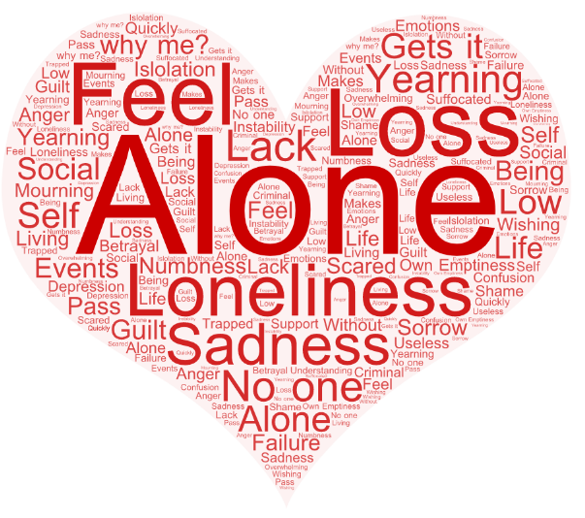

Mental Health Impacts

Several participants feared for their mental health, with one reporting that she displayed ‘symptoms of stress, anxiety and post-traumatic stress disorder’. Report of low mood, low self-esteem and disengagement were also common. Amanda, whose story featured in an earlier section, and who was still going through the process after several years of separation, wrote that she was ‘holding on to my sanity with a vice like grip but if this [their current application] fails, I am scared of my own desperation.’ One participant had attempted suicide, and others had diagnoses of various mental health conditions. Some with mental health problems before their experience of separation found their conditions worsened.
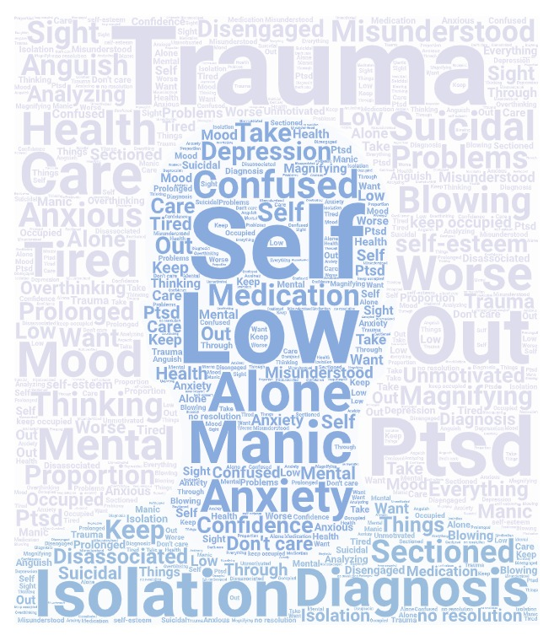

Physical Health Impacts

Participants also described the stress of their situations as bringing on physical health problems. Migraines, palpitations, breathlessness, panic attacks and insomnia were all reported, as were various forms of fatigue and general ill-health. Some linked the experience with hair loss and hormone imbalance, and with changes in their behaviour such as alcohol use, poor diet and self-neglect which in turn led to troubling weight gain or loss which in turn impacted further on their self-esteem.

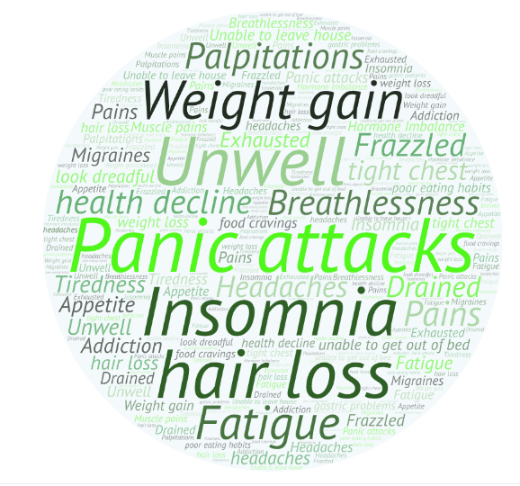

Grace’s Story

Myself and my husband were separated for a total of 11 months and 2 days, due to an incorrect visa refusal. Devastated does not even come close to how we felt. I was overwhelmed by guilt, as the refusal was based on the decision that I did not earn enough as the sponsor. It later transpired that this error was caused by the Home Office losing some of our documentation.

It took us blood, sweat and tears to be reunited – along with several complaints, and endless phone calls, emails and letters. You name it, we tried it. It eventually paid off, but we should have never been put in that position in the first place.

The refusal decision had devastating impacts for both us. The stress took a toll on my mental health, and I lost my job, my dignity and, at my lowest point, almost my life. We were, and still are, broken beyond repair. It will take a long time for us to find some resilience back into our lives.

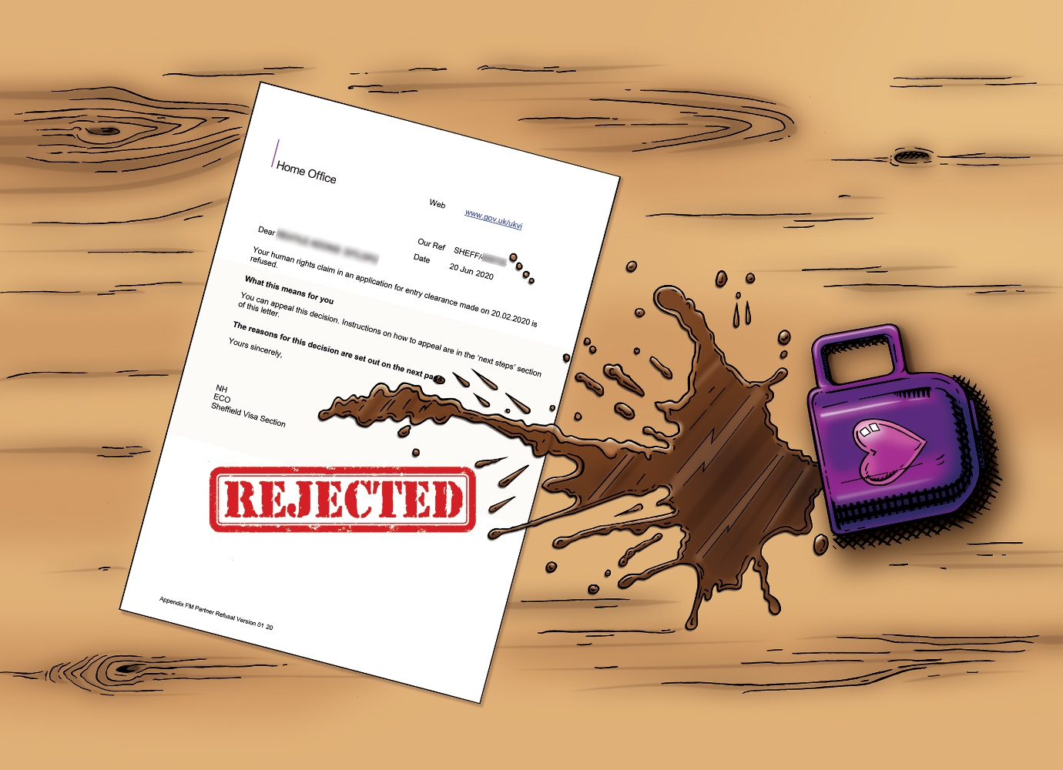

Living with Separation and Uncertainty

Challenges

‘This pressure is hard, no matter where you are. You forget that you summoned up the courage and the strength.’

‘I need to look more positvely rather than looking at negatives. I need to look at my
achievements.’

‘Self-care went out of the window long ago. That makes my mental health and anxiety worse. Not enough exercise’

‘I dive straight into work. I avoid dealing with emotions. I need to think about things.’

‘Be an advocate for your own needs - because no else will.’

What has helped us?

What keeps us going?

Getting Physical  ‘Yoga. I started teaching one day a week. I had to plan and practice. I now teach 5 days a week. Physical movement for me and I’m helping others feel better.’  ‘Exercise helps me. Having a routine to keep my mind together. Going for a run.’  ‘I booked a bi-weekly massage. It gave me physical touch, as my husband wasn’t there.’  ‘I haven’t done enough self-care. I will make a self care budget – low-income massage and exercise.’ | Faith and Family  ‘My children.’  ‘My daughter – or I would have given up.’  ‘My Christian community, faith - even on the worse days. Thinking there is a bigger picture. Looking back at the past and how things have moved. The Church here and in Kenya have offered support fighting our corner.’  ‘Love is what keeps you going’
Time and Space for Myself  ‘I have a space in my house where I put things that are special to me, where I take my time to decompress from the day.’  ‘Lighting a candle helps my stress levels.’  ‘I’m trying to claim some space for myself, to work out how to claim it in nice way. Some quiet space - to let my tides out. Put myself on a list’  ‘A hot bath at night once my son is asleep, listening to a podcast’ | Connecting with Others  ‘Friendships are important to me. You get to know who is there. A couple of friends were  right there. Like a sheath that surrounds you, they hold you.’  ‘The groups and practical advice.’  ‘I have read lots of stories online. I have gooose bumps hearing everyone sharing their stories today. It has touched me to meet people face to face. Quite different to online support.’  ‘Having the online group is great. Coming to a group is great. I feel that I am actually doing  something to improve our situation not just emotional support.’

Daniel’s Story
My experience of being separated by the UK Immigration rules has been one filled with uncertainty, stress and anxiety. Going through this process was extremely difficult for both of us, as we really didn’t know if my wife’s visa application would be accepted, or when we would see each other again.
We got married in Mexico (my wife’s home country). After only being married for one week I had to return to the UK for work. This was very difficult time for us. Straight away we had to start collecting as much evidence as possible to prove to someone who does not know our relationship that we are a legitimate couple. We had no idea how to apply for the visa, and the government websites were not useful at all. Our main help in getting through this process were the fantastic groups on Facebook who guided us through the process. We are extremely grateful to many people in Reunite Families UK for their help – it wouldn´t have been possible without them.
Unfortunately, whilst we were applying for the visa I was going through a redundancy process, which made it even more difficult for us. I felt very anxious throughout this process and rang the immigration line many times to see if there was any development on our visa. They were never able to give me a reason for the delay. This is when I made the decision to go over to Mexico to see my wife, as we really didnt know when we would see each other. The Home Office give a number of days within which they expect to respond to each application, but that had already passed and we had no response to say whether we would get a “Yes” or a “No”.
The amount of money we have had to spend is phenomenal. I really didn´t think it would be this much – I know it will increase even more with the next visa we will need for her to stay in the UK. This is always a concern – that we will not have enough money to pay for the visa.
It took 9 months from marriage for us to get our “Yes” for my wife to be able to join me in the UK. Although others in the group have waited longer, last year was definitely one of the worst and best years of my life. Being separated for so long and then finally getting our answer has filled me with lots of emotions and has affected both of us.
We are still struggling going through this process – nothing has been clear about what the next steps are. It is really a learning curve, but with the help and support we have received from all these amazing groups online we feel supported and hopeful that we will be able to get the next visa.

Conclusion

Restrictions to family immigration have been justified on the basis of benefits to British society and economy – protecting the public purse and enhancing integration. These arguments are open to challenge – even before the 2012 restrictions, family migrants did not have access to public funds, and it is clear that for British citizens and long-term residents deprived of partners and family life the consequences are far from ‘integrating’. The negative impacts of the UK’s family immigration regulations (and how they are put into practice) deserve more attention. For the participants in this project, these included not just the emotional impacts of separation from their partners, and of children from parents, but financial, mental and physical hardship. Some of the periods for which people were kept apart – a few months, a year or two – may not seem long in comparison with the lengthiest of seven years. But whatever the timespan, the possibility during that time that their enforced separation might be permanent created a trauma (for both partners and children) much greater than had the duration been known from the outset. For some, the separation is ongoing.
We are grateful for the generosity of the participants in sharing their time and words to cast light on these difficult experiences. Their accounts show how the already considerable challenges of navigating the UK’s spousal immigration requirements do not exist in a vacuum, but are entwined in people's lives with other more mundane processes and challenges of various kinds. The stresses of separation and the visa system take their toll, but the impacts of these pressures on couple’s abilities to meet visa requirements go unrecognised. And when lives take a difficult turn – health crises, redundancies, or the impact of political crises on lives abroad – the inflexibility of the family immigration system can compound the difficulties couples and families experience, enforcing separation and creating the potential for trauma.
One of the members of the research team who had herself been through the process (all but one of our families have had personal encounters with the family immigration system) described the experience immigration process as akin to ‘gas lighting’– faced with the State’s denial of the validity or importance of their relationships, people sometimes felt as if they were going crazy. The experience of the workshops reinforced the value of collaborative action, coming together, and sharing their stories – providing reassurance that struggling to cope is not abnormal, but a common and shared experience.
The energy which participants brought to this project is all the more impressive given that it took place whilst the 2020 Coronavirus crisis was unfolding. After our first face-to-face workshop, social distancing requirements meant that the remainder of the co-creation process moved online. The Coronavirus pandemic created particular impacts for those kept apart from their partners, heightening many of the pressures and uncertainties documented here: parents struggled to combine sole responsibility for home schooling children whilst also being sole-earners; those in the process of demonstrating six months of minimum income were devastated by loss of earnings; flights, visa and testing appointments were cancelled; and the lack of clarity over whether the spousal immigration system would allow for the impacts of the virus added further anxiety. As Amanda, still separated from her husband Freddy simply put it, ‘everything has gone wrong’.
Of course, this has also been a time when many more people have experienced enforced separation from family members, not by immigration regulations, but by travel restrictions and social distancing measures. As we write, we hope that amid the recovery from the impacts of the virus, the lessons of renewed empathy for couples and families kept apart will endure and inspire a movement for change.

Love in a time of Covid-19: Lilly’s Story

This Friday, 3rd April, was supposed to be the day; the day we have waited for, worked for, longed for. A day fuelled with anxiety; a day that should have symbolised such hope; the first day of the rest our lives. Some might relate these feelings to their wedding day, but somehow this feels bigger, for the 3rd of April was the day we were supposed to submit my husband’s application for a UK spouse visa.
For us, our journey already seems like it has gone on forever, but in reality, we are only just setting out. Over the past six months I have moved across continents for the benefit of my mental health – torn between the love of my husband and the much-needed support of my mum, my family, my friends. Choices, tough choices, the never-ending list of tough choices. But our situation was so much better than all the horror stories we had read. For most of the time, my husband’s two-year visit visa meant he was able to enter the UK with me. Honestly, with my mental state the way it was (so severe it had driven me, us, back to the UK and away from the things we loved so dearly in Kenya), if we had had to endure prolonged separation I think it would have just about killed me.
When you first fall in love, it’s like the whole world comes to a stop. Nothing else matters. It’s like the rest of the world just melts into the background and there is only you; you and the object of that love; my husband and I. Never had we realised the tangle of legislation, rules, processes, MESS, that our love would lead us into. To be honest, we had never imagined we would need to come back to the UK. But life has a funny way of turning everything on its head. For us, that curve ball came in the form of an ectopic pregnancy, emergency surgery and an ensuing attack of PTSD. When I left hospital in Nairobi, I lost myself. Anxiety took over, I had no control. The next six months were a living nightmare. Then the call to come home. It was as if my family and friends woke me up from a horrible dream, and as I awoke, I was back in the UK; back home, a place of safety and sanctuary.
We knew then that we needed to sort out my husband’s immigration status, so that he could be here with me permanently, or at least until I was fully healed. Then we could carry on with our dreams and the purpose in life we had found in Kenya – taking care of orphans and vulnerable children. After two weeks in the UK we already had an appointment with an immigration lawyer to examine our options and find out what we need to do. Naïve as we were, we were still full of hope that this was the start of our next chapter. We thought it would be easy – it’s not as if we are trying to con the system. We had already shown the Home Office that we were genuine, that our love was true – we had had to do that to be able to marry in the UK and to get a marriage visit visa.
The day before our appointment with the immigration lawyer – bang! Another emergency surgery, another baby gone. Our world torn apart once again!
So – a little later than planned – we finally met our immigration lawyer. After the traumas of the last months, we entered the meeting filled with hope, excited at the prospect of my husband securing a spouse visa. How wrong could we have been? Leaving her office, I broke down in tears. The web of UK immigration law she had outlined was just too much to handle. How many hoops do we need to jump through? The Minimum Income Requirement? The list of evidence needed – it almost seemed impossible.
Refocus. I need to get a job. My mental health isn’t great and the last thing I need is to be working, but what choice do I have? £18600 minimum income – OK, I can do that. Apply, apply, apply. October – the 6-month countdown has begun. Work, work, work – one thing to tick off the evidence list. My husband is still here for now on his visit visa, but what kind of life is that for him? He can’t work, can’t volunteer, basically can’t leave the house without me. Now it’s his turn – depression creeps upon him as I continue to work, work, work.
Christmas comes and goes, and then it’s time to say goodbye. We don’t want him to breach his visa rules, so he heads back to Kenya until we are ready to apply. He is back in March – English exam passed, TB test completed. We just need to complete the application and he can return to Kenya for his biometrics appointment and to await our BIG FAT YES. One final bank statement needed: “Please Mr Bank Manager, can you just stamp this one bank statement?”….. “NO, it is against our policy – wait for a postal one to be sent.” We’ve waited this long; I suppose another 10 days isn’t going to matter… or so I thought.
COVID-19 – I am yet to decide if you are a blessing in disguise or just another chapter in a never-ending nightmare. My husband’s flight is cancelled, but at least he is here with me. The private company who process UK visas are closed for six weeks. When will we ever get to apply now? All the evidence we had will now be out of date. There’s the cost of a new TB test (if we can even get one – no tests available in the UK, and no flights to Kenya), and running around trying to get newly dated employer letters, bank statements etc. Everything we have been working so hard towards – what does it mean now? His visit visa runs out in summer. What will happen then?
So much confusion, stress, the anxiety about our future still hanging over our heads, but if I knew all of this in the beginning, when we first fell in love would I change it? End it? Do things differently? Well no – I love my husband and together life is somehow perfect. UK immigration is a thorn in our flesh right now, but it will never stop us loving one another, never stop us being who we are and doing what we have been purposed to do. Yes, I long for the day it is all over, and we will be able to just be, without the judgement and scrutiny of the ridiculous and inhumane UK immigration system.

Sources of Support

If you have been affected by the issues raised here, or to get involved in campaigning on the issue, the following is a list of some of the groups and organisations working in this area:

Reunite Families UK:
Support and campaign group focused solely on the impact of spouse visa rules on families https://www.reunitefamiliesuk.co.uk/
Joint Council for the Welfare of Immigrants:
Migrant-focussed charity providing support, advice and campaigning for the rights of migrants and others affected by the UK immigration system: https://www.jcwi.org.uk/
BritCits:
Campaign group for international/divided families: http://britcits.blogspot.com/
Free Movement:
News and advice on UK immigration law: https://www.freemovement.org.uk/
Facebook groups:
I Love my ‘Foreign’ Spouse
The Surinder Singh Route
Reunite Families UK also has an active Facebook group.

If you are concerned about your own health and wellbeing, you may find it helpful to complete this NHS mood quiz, which can also signpost you to sources of support:
https://www.nhs.uk/conditions/stress-anxiety-depression/mood-self-assessment/

References

Agusita, E. (2018) Visualising Love: Family Migration, Separation and Communication. [Exhibition] SPACE, Bristol, UK. 30 July – 3rd August. [Project website] http://vizlove.org/
Agusita, E. (2019) Relationships at Risk: Family Migration, Regulation and Communication. In Risky Relationships: Navigating Immigration Regulation in Family and Intimate Relationships. [Workshop] Arnolifini, UK. 27th – 28th March.
Bulman, M. (2019) More than half of immigration appeals now successful. The Independent 13th June https://www.independent.co.uk/news/uk/home-news/immigration-appeals-home-office-success-rate-windrush-migrant-crisis-a8957166.html
Charsley, K. (2013) Transnational Pakistani Connections: marrying ‘back home’ Routledge
Children’s Commissioner (2015) Skype Families: the effects on children of being separated from a mum or dad by recent Immigration Rules. 9 September. Available at: https://www.childrenscommissioner.gov.uk/wp-content/uploads/2017/06/SkypeFamilies-CCO.pdf
Joint Council for the Welfare of Immigrants (2020) Families on the Frontline https://www.jcwi.org.uk/families-on-the-front-line
Sumption, M., & Vargas-Silva, C. (2019). Love Is Not all you Need: Income Requirement for Visa Sponsorship of Foreign Family Members. Journal of Economics, Race, and Policy, 2(1-2), 62-76. https://link.springer.com/article/10.1007%2Fs41996-018-0022-8 (open access)
Menski, W. (1999) South Asian Women in Britain, Family Integrity and the Primary Purpose Rule’ in R. Barot, H. Bradley and S. Fenton (eds) Ethnicity, Gender and Social Change London: Macmillan
Mohabir, R. (2018) Leaving our Homeland: Syria to the Isle of Bute Trauma Awareness
Ministry of Justice (2019) Tribunal Statistics Quarterly, January to March 2019 (Provisional)
Newman, D. (2017) Divided families and the immigration rules: a partial victory for British citizens with foreign spouses, Journal of Social Welfare and Family Law
Sachdeva, S. (1993). The primary purpose rule in British immigration law. London: Trentham Books.
Wray, H. (2011). Regulating Marriage Migration into the UK. A Stranger in the Home. Farnham: Ashgate.

Back Cover

Thousands of British families have experience separation as a result of immigration restrictions brought in in 2012. This collection of narratives and illustrations highlights the pressures of navigating the UK family immigration system, and the profound impacts on individuals and families kept apart from their loved ones.
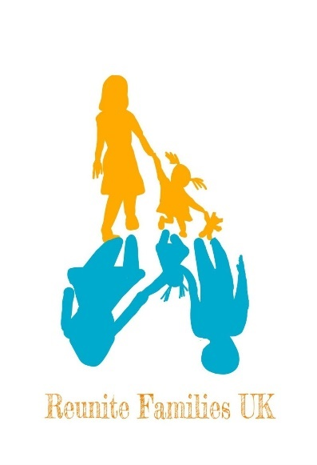
IN COLLABORATION WITH

See https://www.reunitefamiliesuk.co.uk/copy-of-our-families-stories-2 for issues documented by Reunite Families UK on the impacts of the Covid-19 crisis on their members, and JCWI’s Families on the Frontline report).

